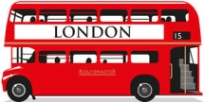 LET’S GO TO LONDON !!

- Look at the map !

What is this symbol ? 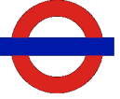
bus stations the underground (the tube) stations shops monuments

Look at those pictures : Where are they in the map ? Can you name them ?

EXAMPLE :
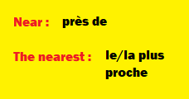
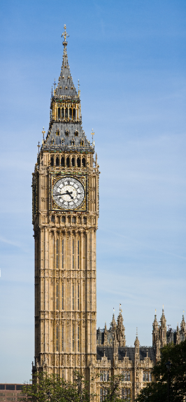

This is Big Ben .

It is on White Hall Street.

It is next to Westminster Abbey and the nearest station is Westminster station.

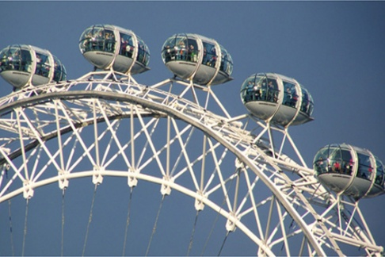
This is the _______________________ .
It is _______________________________________
___________________________________________
___________________________________________
___________________________________________

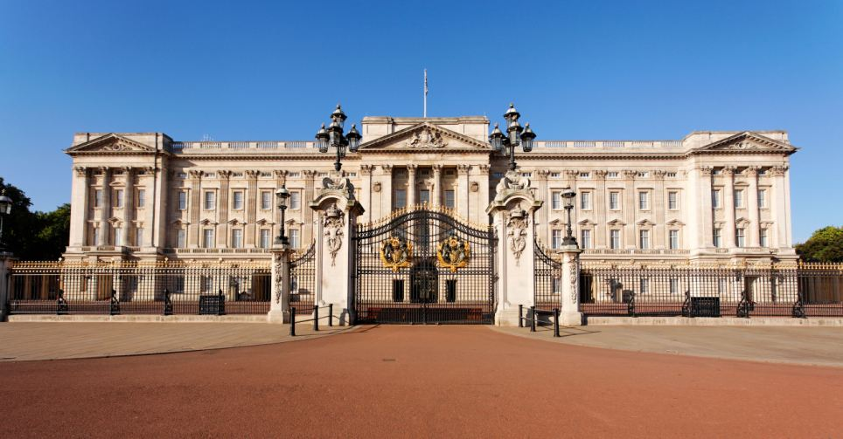
This is _______________________________ .
It is __________________________________________
______________________________________________
______________________________________________

